SELF-GOVERNMENT DEVELOPMENT INSTITUTE

Action 1.3 of Youth in Action Programme
Project: Community engagement for active democracy
20th-26th of July 2009

There is nothing simpler than this chart:
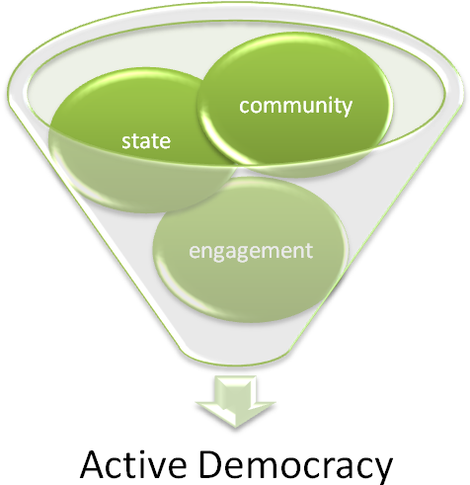
When you live in the democratic state with an open minded community eager for being engaged in all decision making and implementation processes of their homeland - you are able to mix these three components and have the most valued result in XXI century – ACTIVE DEMOCRACY.
As all EU states are democratic and have open minded communities there is only one step left and ACTIVE DEMOCRACY will be obtained.
The most important is to activate and engage young people. Young people always look for something interesting, new, and undiscovered before. If you want to engage young people – you must be able to introduce them interesting engagement process as for them to become interested in staying and working, discussing, implementing projects for the future.
All components which were mentioned above encouraged us, the team of Self-Government Development Institute, to implement our new project “Community engagement for active democracy”.

Main project idea:

- As it is of a high importance to introduce interesting but rarely, in the activity of youth organizations, used engagement methods and tactics this project is designed to try those methods by ourselves and to evaluate their suitability for youth organizations and youth engagement in democracy processes of our countries.

- Small groups, composed of citizens of different countries according to gender balance principle, are going to discuss two topics. Both topics are going to be discussed through democracy implementation prism. One of them – elections of the European Parliament – is political; other – managing climate change – is social. These discussions are going to be organized using community engagement methods such as:
  - Fishbowls
  - Design workshops
  - Photovoice
  - Planning for real (3D)
  - World cafe
  - Democs
  - Forum theatre
  - Future search conference

- All groups will try all methods and members of the groups are going to be changed from time to time. By discussing interesting topics all participants will discover which engage methods are mostly useful and most interesting for young people. The last part of the project is presentation of insights all participants had an opportunity to create during one week active work.

Some of the project results:

- Participants of the project actively engaged in all project activities. Engagement is the most important part of democratic society

- Youth organizations discovered new engagement methods and techniques and by discussing them all together evaluated their suitability for youth organizations in different countries

- Young people discussed two very important topics – results of European Parliament elections and possibilities of young people and communities to manage climate change. Both topics are inseparable parts of democracy process of EU.

- New viewpoints and new partners for future cooperation.

Self-Government Development Institute:
Self-government development institute is innovative, dynamic and results oriented non profit organization. It was established by two competent youth leaders, who had very clear and inspirating vision of how young people must strengthen their positions in every day life of their country. Self –government development institute covers three main activity groups:
- Work with citizens – activities in this field are associated with youth and youth workers same as different communities;
- Coopration with business sector – this field is seen as encouragement of small enetrprises and enterprising society members, particularly youth;
- Work with municipalities – Institute, in collaboration with municipalities, creates strategies in such fields as culture, youth, social security, education, sport etc., helps to implement those strategies, helps youth organizations to attract sponsorship.
Members of the Institute are young people who already have valuable experience in all mentioned fields – we work together in developing new points of view and new means of implementation of youth activities. Our aim is to encourage young people to look wide and to become capable of identifying their needs, problems and objectives, to realize that young people are strong in their innovative ideas, enthusiastic activities and optimism. Young people are future and we, by working together, have to reveal this fact in our societies by nurturing tolerance, understanding and public spirit of all young people.

Don’t ever forget that we are Youth in action and our contribution will let us obtain active democracy!

Become our partners and we will engage youth together!

Write us if you are interested in our project.

Send us your signed, stamped and scanned Part III by e-mail: dorota@savivaldosinstitutas.lt
Same as by post:
Self-Government Development Institute
Liudvinavo str. 37
LT-02241 Vilnius, Lithuania

Application deadline: January 27th, 2009

Contact person:
Dorota Denkovska
E-mail: dorota@savivaldosinstitutas.lt
Phone: +37067407877

